A Comparative Study of Shannon and Nyquist Channel Capacity Models
*A Mathematical and Graphical Analysis*

First Name: Yunlong
Family Name: Wang
Student Number: 3184483
Course: BS3- Networks and Data Communications

Abstract-Channel capacity is a fundamental concept in the study of “Network and Data Communications”. It represents the theoretical maximum information rate at which reliable transmission can be achieved over a given communication channel, typically measured in bits per second (bit/s). This technical report focuses on the Shannon formula and the Nyquist formula, which also examining the roles of bandwidth and signal-to-noise ratio (SNR). It analyses the channel parameters featured in these formulas, along with the specific numerical values and units assigned during the analysis——to explore the mathematical relationships between them. Furthermore, the report discusses the significance of channel capacity within communication systems and addresses the limitations of this theoretical model when applied to modern network systems.

Introduction

1.1 Background
Channel capacity is the theoretical maximum information rate at which reliable transmission can be achieved over a given communication channel. Reliable communication requires a sufficiently low probability of transmission errors. Data transmission involves quantifying information into a measurable rate, forming a theoretical foundation for communication systems and supporting the development of future communication technologies.

1.2 Research Context
The Nyquist and Shannon models are two fundamental frameworks that define the theoretical limits of communication transmission. Each establishes performance boundaries based on distinct physical constraints, making a comparison between them highly meaningful. The two models are based on different assumptions: the Nyquist model considers the maximum data rate of an ideal noise-free channel whereas the Shannon theorem considers the theoretical capacity of a noisy channel.
These two models are worth comparing because they define transmission limits from complementary perspectives, collectively forming a comprehensive theoretical framework for communication.

1.3 Aim and Scope

1.3.1 Aim
The core objective of this technical report is to compare the Shannon and Nyquist channel capacity models; it also aims to provide an understanding of how both models describe the theoretical limits on transmission rates by examining their respective formulas, assumptions, and key parameters. The analysis will also use numerical calculations, matrix-based data organization, and three-dimensional visualization to examine how changes in the model parameters affect the theoretical data rates.

1.3.2 Scope
This technical report focuses exclusively on the Nyquist and Shannon channel capacity models.
Specifically, various parameter combinations are constructed by varying the bandwidth ‘B’ and the number of signal levels ‘L’ in the Nyquist formula, as well as the bandwidth ‘B’ and the SNR in the Shannon formula. The calculated results for these combinations are organized into matrices, which are then used to generate two 3D surface plots. It should be noted that this is a theoretical analysis based on mathematical formulas; it does not involve measurements of actual network equipment or empirical throughput testing.

Theory

Mathematical Formulation of the Nyquist Model

Nyquist Formula
The Nyquist formula focuses exclusively on bandwidth and the richness of signal states under ideal, noise-free conditions. It derives the theoretical maximum information rate at which reliable transmission can be achieved in the absence of noise, expressed as follows:
$$R_{max}=2B\log_{2}{L}$$
In the formula:
‘$R_{max}$’ stands for Maximum Data Rate; it typically represents a theoretical upper limit and is also measured in bits per second (bit/s).
‘B’ stands for Bandwidth: bandwidth is the range of frequencies that a communication channel can transmit, typically expressed as the difference between the highest and lowest frequencies. Its unit is Hz, which can be represented by the following formula:
$$Bandwidth=f_{max}-f_{min}$$
‘L’ stands for the number of signal levels, and the amount of information that each signal unit can represent is: $\log_{2}{L} bits$.
It is worth noting that this formula accounts only for bandwidth and the modulation order.

2.1.2 Mathematical Derivation
The Nyquist model can be understood by examining the maximum symbol rate in an ideal, noise-free channel. For a channel with a bandwidth of B Hz, the theoretical maximum symbol rate is 2B symbols per second (2B symbols/s). If each symbol can represent L distinct signal levels, then the amount of information carried by each symbol is $\log_{2}{L}$ bits.
Consequently, the maximum data rate is calculated by multiplying the maximum symbol rate by the number of bits represented by each symbol:
$$R_{max}=2B\log_{2}{L}$$
This relationship indicates that the maximum theoretical data rate grows linearly with an increase in bandwidth and logarithmically with an increase in the number of signal levels. However, this model assumes an ideal, noise-free channel and does not account for the impact of noise on signal detection.

2.1.3 Example Calculation
Consider an ideal communication channel with a bandwidth of 6666 Hz and 6 signal levels.
Given: $B=6666 Hz$
$$L=6$$
To solve this question, we need use Nyquist formula:
Substitute the data into the formula (All numerical results are rounded to four decimal places):
$$R_{max}=2B\log_{2}{L}$$
$$R_{max}=2×6666×\log_{2}{L}$$
$$R_{max}=2×6666×\log_{2}{6}$$
$$R_{max}≈34462.7201 bit/s$$
Therefore, the theoretical maximum data rate is 34462.7201 bit/s. This result applies under the ideal, noise-free conditions assumed by the Nyquist model.

Mathematical Formulation of the Shannon Model

Shannon Formula
In contrast, the Shannon formula incorporates a noisy environment, taking into account signal power, noise power, and other forms of channel interference. It is expressed as follows:
$$C_{max}=B\log_{2}\left(1+SNR\right)$$
In the formula:
‘B’ stands for Bandwidth: bandwidth is the range of frequencies that a communication channel can transmit, typically expressed as the difference between the highest and lowest frequencies. Its unit is Hz.
‘C’ stands for Channel Capacity, which refers to the theoretical maximum reliable data transmission rate, measured in bit/s.
‘S’ stands for Signal Power, representing the power of the received signal, measured in W.
‘N’ stands for Noise Power, representing the power of the received noise, measured in W.
‘SNR’ stands for Signal-to-Noise Ratio, which is the ratio of signal power to noise power. It is expressed as follows:
$$SNR=\frac{power of signal}{power of noise}$$

SNR Conversion and Formula Transformation
The SNR describes the relationship between signal power and noise power. It can be expressed either as a linear ratio or in decibels (dB). Linear ratio just mentioned can be understood as the factor by which the signal power exceeds the noise power. When the SNR is given in decibels, it must be converted into a linear value before being substituted into the Shannon formula.
The conversion formula is:
$${SNR}_{\left(Linear value\right)}={10}^{\left[\frac{{SNR}_{\left(dB\right)}}{10}\right]}$$

2.2.3 Example Calculation
Consider a noisy communication channel with a bandwidth of 8888 Hz and a SNR of 30 dB.
Given: $B=8888 Hz$
$SNR=8$
To solve this question, we first convert the ${SNR}_{\left(dB\right)}$ to a linear value using conversion formula, and then use the Shannon formula to obtain the final result:
Convert ${SNR}_{\left(dB\right)}$:
$${SNR}_{\left(Linear value\right)}={10}^{\left[\frac{{SNR}_{\left(dB\right)}}{10}\right]}$$
$${SNR}_{\left(Linear value\right)}={10}^{\left(\frac{30}{10}\right)}$$
$${SNR}_{\left(Linear value\right)}={10}^{3}$$
$${SNR}_{\left(Linear value\right)}=1000$$
Substitute the data into the Shannon formula (All numerical results are rounded to four decimal places):
$$C=B\log_{2}\left(1+SNR\right)$$
$$C=B\log_{2}\left(1+1000\right)$$
$$C=B\log_{2}\left(1001\right)$$
$$C=8888×\log_{2}\left(1001\right)$$
$$C≈88588.7070 bit/s$$
Therefore, the theoretical channel capacity is 88588.7070 bit/s. This value represents a theoretical limit under the specified value conditions, rather than a guaranteed practical transmission rate.

2.3 Mathematical Comparison of the Two Models
Aspect | Nyquist model | Shannon model
Formula | $$R_{max}=2B\log_{2}{L}$$ | $$C=B\log_{2}\left(1+SNR\right)$$
Main parameters | Bandwidth and signal levels | Bandwidth and SNR
Channel assumption | Ideal and noise-free | Noisy
Effect of bandwidth | Linear | Linear
Effect of second parameter | Logarithmic in L | Logarithmic in 1+SNR

The Nyquist model focuses on bandwidth and signal levels, whereas the Shannon model considers bandwidth and the SNR. Both indicate that increasing bandwidth can enhance theoretical capacity, yet they differ in their assumptions regarding noise. These distinctions lay the groundwork for the analysis in Chapter 3.

Mathematical Analysis

Parameter Selection and Calculation
This analysis explores the key characteristics of the Nyquist and Shannon models, as well as the relationship between them. I selected specific parameter values, organized the calculated results into Excel, and imported this data into the ‘OriginPro2024b’ software to generate plots.
For Nyquist model, the bandwidth ranges from 1000 Hz to 10,000 Hz with a step size of 1000Hz, while the number of signal levels is set to 2,4,8,16,32.
For the Shannon model, the bandwidth also ranges from 1000 Hz to 10,000 Hz, and the SNR ranges from 0 dB to 40 dB. For each combination of parameters, I calculated the corresponding maximum data rate or channel capacity using the formulas presented in Section 2. Before applying the Shannon formula, the SNR values—originally in dB—were converted into linear values. These results represent theoretical calculations rather than empirical data measured from a physical communication system.

Nyquist Model Analysis
Figure. 1. Nyquist_2D_Line_Chart
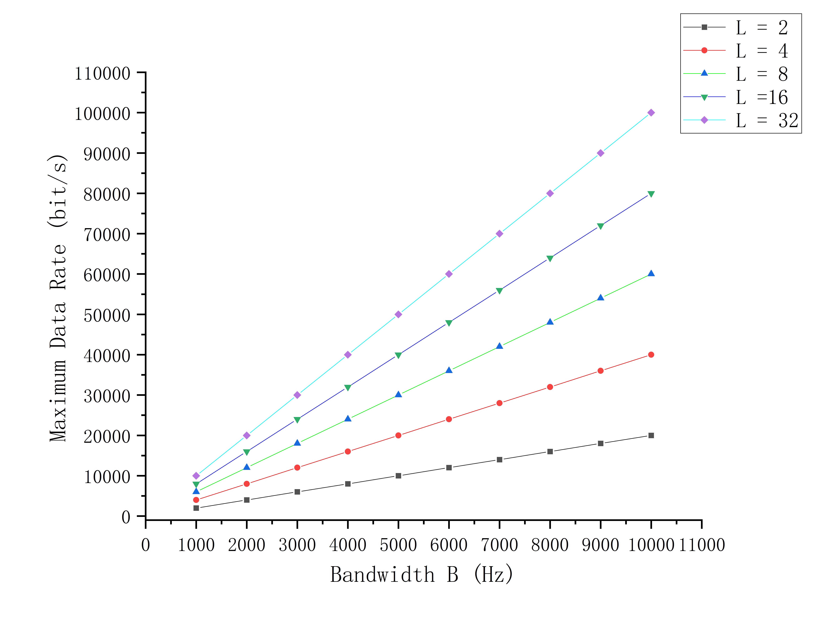
Figure 1 illustrates the relationship between bandwidth and the theoretical maximum data rate for various numbers of signal levels. For a given number of signal levels—letting ‘x’ represent bandwidth and ‘y’ represent the maximum data rate—it is evident that all five curves exhibit a linear relationship as bandwidth increase. This can be expressed more formally by the equation $y=kx$ (where k is the slope) for each respective curve; this confirms that, under the assumptions of this model, doubling the bandwidth results in a doubling of the theoretical maximum data rate.
The results further indicate that, for a fixed bandwidth, increasing the number of signal levels enhances the maximum data rate. With a bandwidth of 10,000 Hz, the calculated data rate rises from 20,000 bit/s when L=2 to 100000 bit/s when L=32. However, as reflected by the $\log_{2}{L}$ term in the Nyquist formula, the relationship between the data rate and the number of signal levels is not linear, but logarithmic.
As can be seen from Figure 1 and the accompanying analysis, the impact of bandwidth is linear, whereas the contribution of the number of signal levels follows a logarithmic relationship.

Shannon Model Analysis
Figure. 2. Shannon_2D_Line_Chart
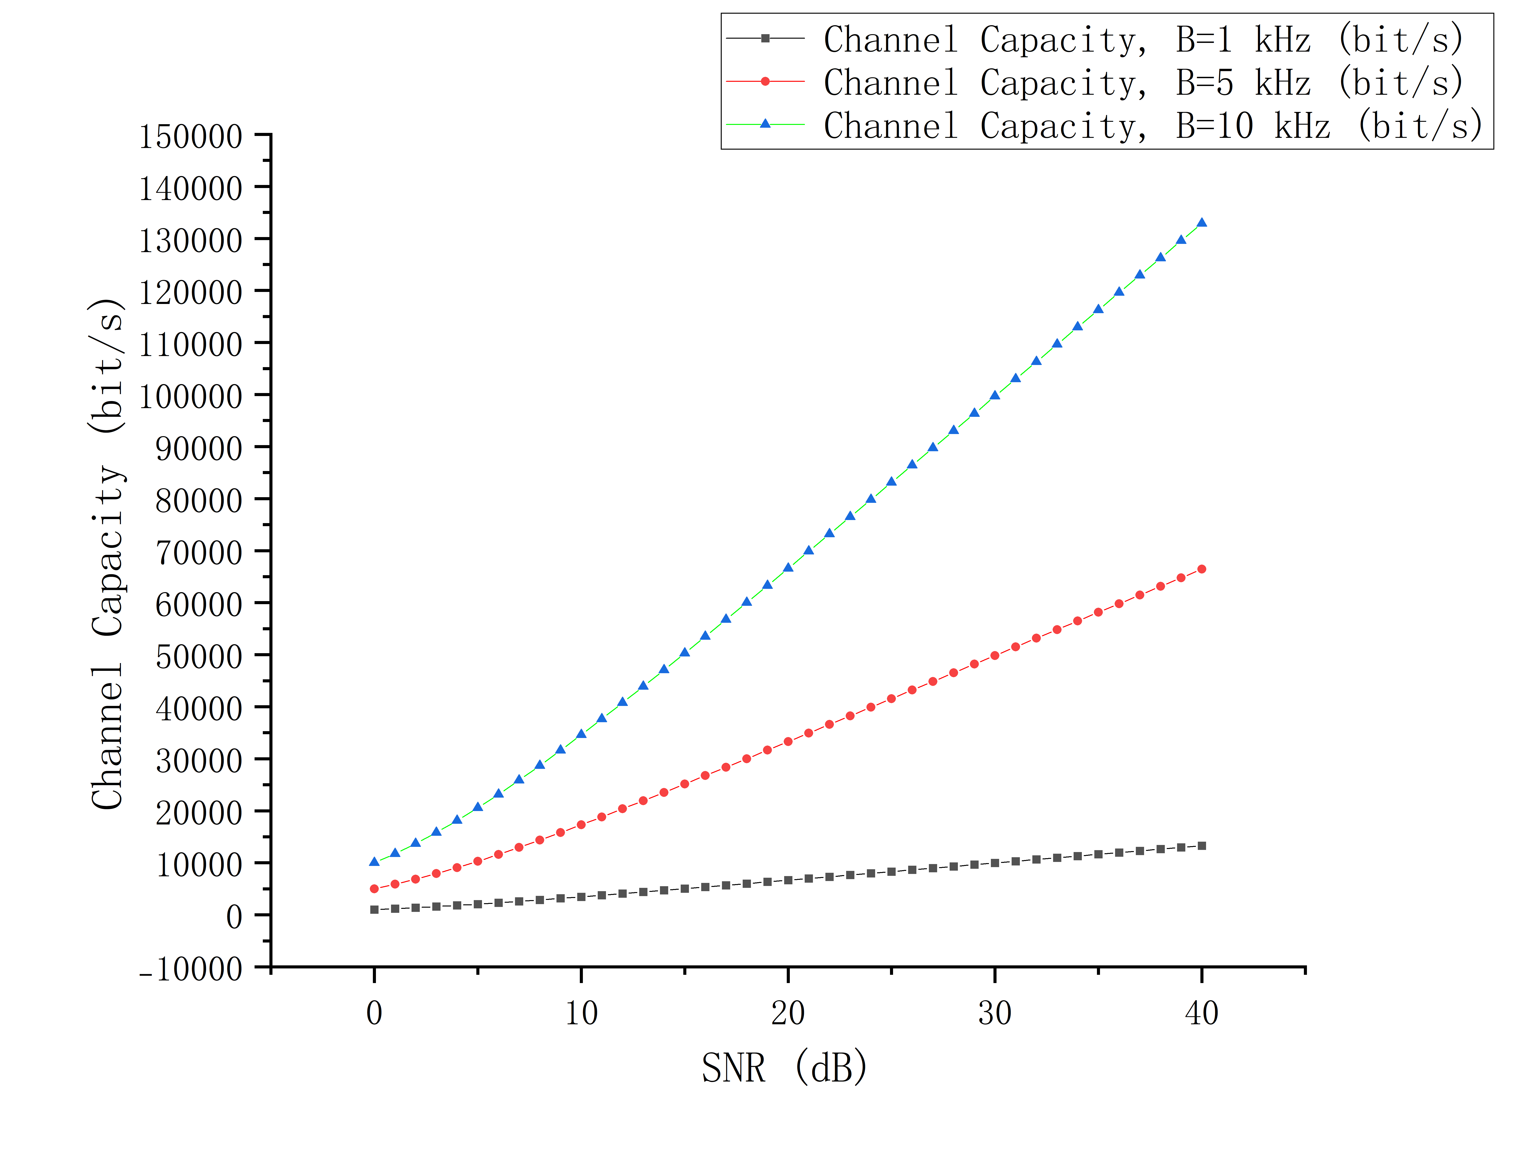
The Shannon model is analyzed by varying the bandwidth and SNR. Figure 2 illustrates the calculated channel capacity as a function of the SNR for bandwidths of 1000 Hz, 5000 Hz and 10000 Hz. The curves rise as the SNR increases, indicating that a stronger signal—relative to the noise—allows for a higher theoretical channel capacity.
For a fixed SNR, the channel capacity is directly proportional to the bandwidth. Consequently, at the same SNR, the channel capacity with a 10000 Hz bandwidth is ten times that of a 1000Hz bandwidth. In contrast, increasing the SNR does not result in a linear growth in channel capacity. Due to the logarithmic term in the Shannon formula, while the channel capacity continues to increase, the incremental gain in capacity provided by a given increase in SNR gradually diminishes once the SNR is already sufficiently high.

Conclusion
The technical report provides a statistical analysis and comparative characterization of channel capacity based on the Nyquist and Shannon models, utilizing matematical analysis and formula-based calculations. The analysis of the Nyquist model demonstrates that the maximum theoretical data transmission rate increases linearly with bandwidth. The analysis of the Shannon model shows that channel capacity increases linearly with bandwidth and logarithmically with the linear SNR. When the SNR is expressed in dB, the capacity curve approaches a linear relationship at higher SNR levels.
Althrough both models describe theoretical transmission limits, they are based on different assumptions. The Nyquist model assumes an ideal, noiseless channel, whereas the Shannon model accounts for the impact of noise on channel capacity. In practical communication systems, the achievable data rate may be lower due to factors such as interference, coding overhead, and implementation constraints.
In summary, these two models offer complementary perspectives of communication channels. The theoretical calculations presented in this report demeonstrate the mathematical relationships between channel parameters and transmission limits, establishing a foundation for the analysis of digital communication systems.

References

